**COMPUTING CLOUD USING IBM CLOUD**

For this project we used the following elements:

* Two drones that are connected to node-red (This Node-RED is installed in Local Computers) we called Node-Red-Local 1 and Node-Red-Local-2.
* One robot that are connected to node-red (This Node-red is installed in a PC) we called Node-Red-Local 3
* IBM Cloud: In this account we used the Aplication Node-RED. we called Node-Red-Cloud.

Important to make clear that Drones and Robots we are simulated with Arduinos and one PLC.

Basically the main idea for this project is that both drones using its cameras can identify if there is any garbage in a lake and then the drones will send a signal to its Node-Red Loca 1 or Node-Red-Local 2. After that, this Node-Red-Local will send a signal to Node-Red-Cloud and it will send the command throw Node-Red-Local 3 to the Robot. Finally the robot got the instrucction to collect this garbage and will send a feedback that the garbage is alredy picked.

In the proceess in Node-red-Cloud the location point is sended by Telegram for other users in the case Robot cannot pick the garbage.

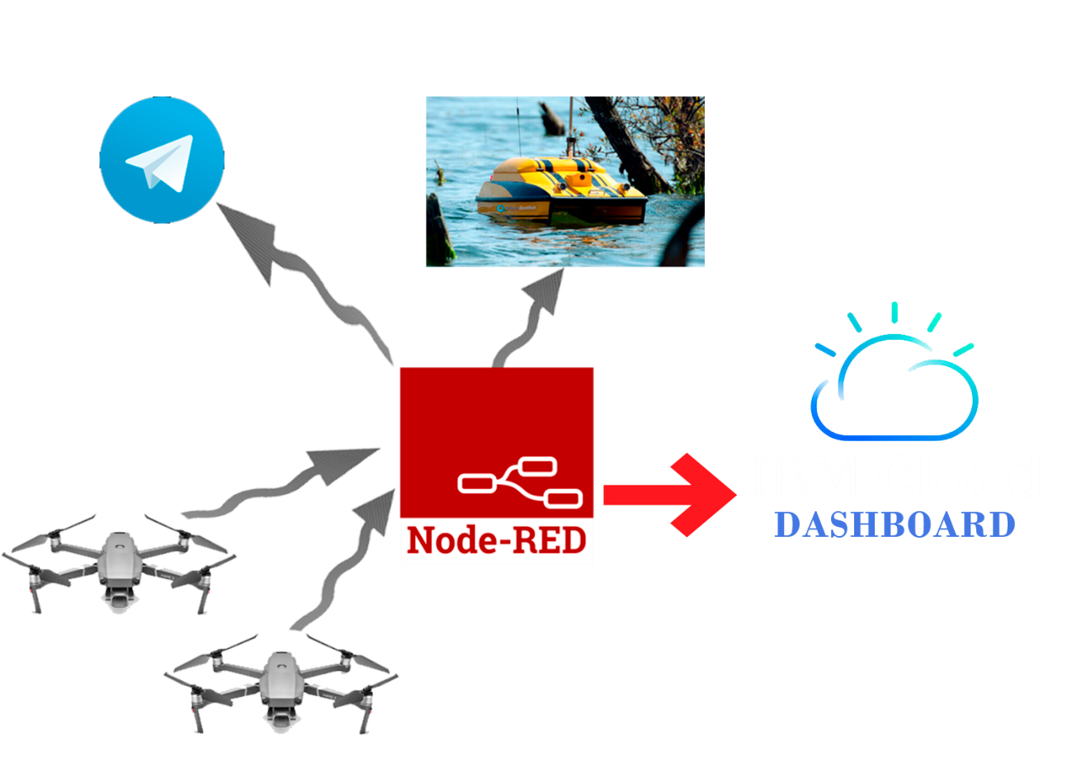

Bellow is the scheme for Node-Red-Cloud

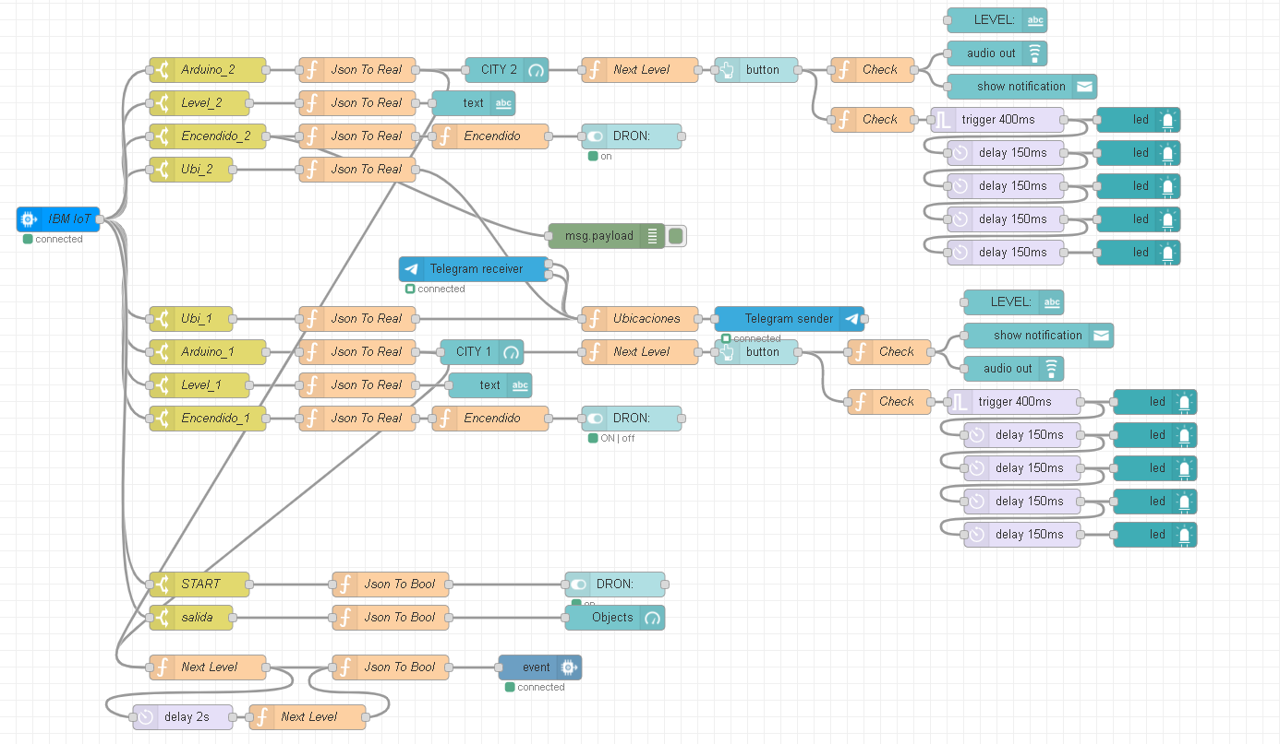

Bellow is the dashboard from Node-Red-Cloud: The important to use Node-Red-Cloud is that this screen can be showed from anyplace in the world.

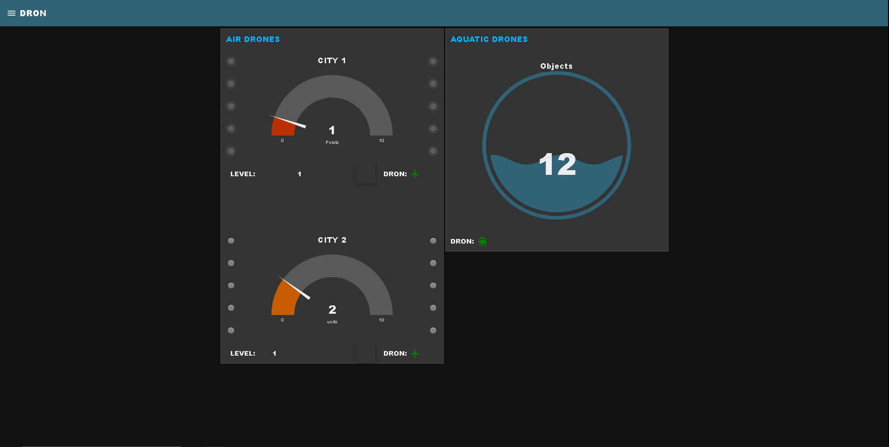

When Node-Red-Cloud got a signal from Dron 1 or Dron 2 that there is any garbage automatically send a signal by Telegram that show to the other user where is exactly point in where the garbage is.

